Automatic License Number Plate Recognition System

### A PROJECT REPORT

***Submitted by***

NAMAN RAJ YADAV (21BCS11862)

***in partial fulfillment for the award of the degree of***

# BACHELOR OF ENGINEERING

**IN**

COMPUTER SCIENCE ENGINEERING HONS. (ARTIFICIAL INTELLIGENCE AND MACHINE LEARNING)



**Chandigarh university**

**2023**



# BONAFIDE CERTIFICATE

Certified that this project report **“Automatic License Number Plate Recognition System”** is the bonafide work of **“Naman Raj Yadav”** who carried out the project work under my/our supervision.

**SIGNATURE SIGNATURE**

#### AMAN KAUSHIK ……….

**HEAD OF THE DEPARTMENT SUPERVISOR**

#### AIT-CSE AIT-CSE

Submitted for the project viva-voce examination held on……………………

**INTERNAL EXAMINER EXTERNAL EXAMINER**

# TABLE OF CONTENTS

**Abstract** 4

**Keywords and Abbreviations……………………………………………………..** 5-6

**Chapter 1…**……………………………………………………………………………..

### 1.1 Detailed Introduction of the project………………………………………

**1.2 Region of Interest (ROI) Analysis**……………………………………………

**Chapter 2.**

**2.1. Bibliometric Analysis**

**2.2. Problem Definition**

**2.3 Goals and Objectives**

**2.3.1. Goals**

**2.3.2. Objectives**

**Chapter 3.**

**3.1. Concept Generation**

### 3.2. Selection of Specifications/Features

### 3.3. Design Constraints

**3.4. Design Flow**

### 3.5. Best Design selection

### 3.6. Implementation plan

**Chapter 4**

**4.1 Analysis of Design Drawings/Schematics/Solid Models**

**4.2 Report Preparation and Project Management**

**4.3. Results and output for the project**

**Chapter 5**

### 5.1. Appendix

**References** ...………………………………………...…………………………………...

## 

# ABSTRACT

The Automatic License Number Plate Recognition (ALPR) System is a comprehensive and advanced solution for the recognition of license number plates in images and videos. This project leverages the power of computer vision and deep learning to accurately detect and extract characters and digits from license plates. OpenCV is employed for initial number plate detection, while Py-Tesseract is utilized for character recognition. These components form the foundation for the ALPR system, enabling it to efficiently process diverse license plates in various scenarios.

The novel addition to this project is the integration of deep learning techniques, such as Convolutional Neural Networks (CNN), YOLOv8, SSD, R-CNN, and Keras. By incorporating these cutting-edge technologies, the ALPR system achieves remarkable accuracy and robustness in recognizing license plates, even in challenging conditions like low lighting or partial plate occlusion.

The ALPR system not only identifies license plates but also provides potential applications in security, traffic monitoring, and smart city initiatives. This project showcases the fusion of traditional computer vision methods with state-of-the-art deep learning approaches to create a highly effective and versatile license plate recognition system. It serves as a valuable resource for researchers and developers interested in automatic number plate recognition and sets a new standard in this field.

# KEYWORDS

# ALPR

# License Plate Recognition

# Computer Vision

# Deep Learning

# Convolutional Neural Networks (CNN)

# OpenCV

# Py-Tesseract

# YOLOv8

# SSD (Single Shot MultiBox Detector)

# R-CNN (Region-based Convolutional Neural Network)

# Keras

# Image Processing

# Object Detection

# Character Recognition

# Number Plate Detection

# OCR (Optical Character Recognition)

# Image Analysis

# Vehicle Identification

# Automatic Number Plate Recognition

# Machine Learning

# Image Segmentation

# Traffic Monitoring

# Security Systems

# Smart Cities

# Deep Learning for Computer Vision

# Abbreviations:

1. ALPR - Automatic License Plate Recognition
2. CV - Computer Vision
3. DL - Deep Learning
4. CNN - Convolutional Neural Network
5. OpenCV - Open Source Computer Vision Library
6. OCR - Optical Character Recognition
7. YOLO - You Only Look Once
8. SSD - Single Shot MultiBox Detector
9. R-CNN - Region-based Convolutional Neural Network
10. API - Application Programming Interface
11. ROI - Region of Interest
12. GPU - Graphics Processing Unit
13. FPGA - Field-Programmable Gate Array
14. LPR - License Plate Recognition
15. DNN - Deep Neural Network
16. ANN - Artificial Neural Network
17. ROI - Region of Interest
18. SVM - Support Vector Machine
19. IoT - Internet of Things
20. USB - Universal Serial Bus
21. HOG - Histogram of Oriented Gradients
22. GUI - Graphical User Interface
23. FPS - Frames Per Second
24. TP - True Positive
25. FP - False Positive

**CHAPTER – 1**

**INTRODUCTION**

### Detailed Introduction of the project:

The Automatic License Number Plate Recognition (ALPR) System project is a cutting-edge initiative designed to tackle the increasingly critical need for automated license plate recognition across a broad spectrum of applications. License plate recognition has evolved into an indispensable technology with far-reaching implications, encompassing law enforcement, traffic management, parking systems, and security solutions.

Traditional ALPR systems often rely on rule-based methods for license plate detection and recognition. However, these methods come with inherent limitations, such as susceptibility to variations in lighting conditions, plate orientations, and font styles. To overcome these challenges and enhance the accuracy and reliability of license plate recognition, this project integrates state-of-the-art technologies like computer vision and deep learning.

At the core of the ALPR system are several key components, including OpenCV, Pytesseract, and various deep learning models such as Convolutional Neural Networks (CNN), YOLOv8, SSD (Single Shot MultiBox Detector), and R-CNN. Each of these components plays a crucial role in the ALPR system:

OpenCV, an open-source computer vision library, is primarily responsible for the initial license plate detection phase. OpenCV offers a wide array of tools and algorithms for image preprocessing, object detection, and image segmentation, which are fundamental for isolating license plates within complex scenes.

Pytesseract, a Python library built on the Tesseract-OCR engine, is employed for character recognition. It extracts alphanumeric characters and digits from the detected license plates, serving as the optical character recognition (OCR) component that translates the license plate information into a readable text format.

The novel aspect of this project lies in the integration of deep learning models. Convolutional Neural Networks, YOLOv8, SSD, and R-CNN are used for object detection and feature extraction. By incorporating these advanced models, the ALPR system achieves an unprecedented level of accuracy and robustness, making it capable of accurately detecting license plates even in challenging conditions, such as low lighting, adverse weather, or partial plate occlusion.

The fusion of traditional computer vision techniques with cutting-edge deep learning approaches positions this project as a pioneering solution in the field of license plate recognition. Its versatility and adaptability enable it to handle various license plate formats, fonts, and languages, making it suitable for a diverse range of real-world applications.

Beyond its fundamental capabilities in license plate recognition, the ALPR system has the potential to revolutionize security systems, traffic management, and smart city initiatives. The data collected by the ALPR system can be leveraged for traffic analysis, parking space management, law enforcement, and more, contributing to safer and more efficient urban environments.

**1.2 Region of Interest (ROI) Analysis**

The Region of Interest (ROI) analysis within the Automatic License Number Plate Recognition (ALPR) System project is a fundamental component that plays a critical role in enhancing the system's efficiency and accuracy. ROI analysis involves the identification and isolation of the specific areas within an image or video frame that are likely to contain license plates. This process is crucial as it reduces computational load and minimizes the chances of false positives, improving the overall system's speed and precision.

Through the integration of computer vision techniques and deep learning models, the ALPR system excels in identifying these ROIs. OpenCV, in particular, is instrumental in pinpointing potential license plate locations within the image. By concentrating computational efforts on these ROIs, the system streamlines the subsequent steps of character recognition and plate identification, thereby optimizing the entire ALPR process.

The ROI analysis, as an integral part of the ALPR system, contributes significantly to its robustness and adaptability, allowing it to excel in various scenarios and environmental conditions. By isolating regions of interest with precision, the system can function effectively in scenarios with challenging lighting conditions, vehicle orientations, and plate styles. In essence, the ROI analysis is a key factor that enables the ALPR system to deliver reliable and real-time license plate recognition in a wide array of applications, from security and traffic management to smart city initiatives.

### CHAPTER – 2

**LITERATURE SURVEY**

### 2.1. Bibliometric Analysis

##### Proposed solution by different researchers

Literature Survey on Automatic License Plate Recognition (ALPR) Systems

Automatic License Plate Recognition (ALPR) systems have evolved significantly, with the integration of deep learning and computer vision techniques contributing to improved accuracy and real-time processing capabilities. This literature survey provides an in-depth exploration of key references in the field:

**1. "A Two-Stage Deep Neural Network for Multi-norm License Plate Detection and Recognition"** **[1]** by Yousri Kessentinia et al. introduces a sophisticated two-stage deep neural network architecture designed to enhance the precision of license plate detection and recognition. The study showcases the effectiveness of this approach in accommodating various license plate formats and norms.

**2. "Real-time Jordanian License Plate Recognition using Deep Learning"** **[2]** by Salah Alghyaline presents a real-time ALPR system tailored for Jordanian license plates. Leveraging deep learning, this system demonstrates the feasibility of accurate and efficient recognition within the unique context of Jordanian license plates, addressing specific regional requirements.

**3. "A Robust Real-Time Automatic License Plate Recognition Based on the YOLO Detector" [3]** by Rayson Laroca et al. adopts the YOLO (You Only Look Once) object detection model to develop a robust real-time ALPR system. This reference showcases the integration of YOLO to achieve swift and reliable license plate recognition.

**4. "Vehicle License Plate Recognition using Visual Attention Model and Deep Learning" [4]** by Di Zang et al. explores the fusion of a visual attention model with deep learning techniques for vehicle license plate recognition. The study focuses on improving recognition accuracy by mimicking human visual attention patterns.

**5. "A Robust Deep Learning Approach for Automatic Iranian Vehicle License Plate Detection and Recognition" [5]** by Ali Tourani et al. introduces a robust deep learning approach designed for the automatic recognition of Iranian vehicle license plates. The system exhibits resilience to challenging environmental conditions and diverse plate formats.

**6. "LPRNet: License Plate Recognition via Deep Neural Networks" [6]** by Sergey Zherzdev and Alexey Gruzdev presents LPRNet, a dedicated deep neural network architecture optimized for license plate recognition. This reference highlights LPRNet's efficiency and accuracy, making it a notable contribution to the field.

**7. "Deep Learning System for Automatic License Plate Detection and Recognition" [7**] by Zied Selmi et al. details a comprehensive deep learning system tailored for ALPR. The study showcases the system's capability to operate seamlessly in various scenarios, from traffic management to security applications.

**8. "Research on License Plate Recognition Algorithms Based on Deep Learning in Complex Environment" [8]** by Wang Weihong and Tu Jiaoyang delves into the research on license plate recognition in complex and challenging environments. The reference emphasizes the utilization of deep learning techniques to enhance recognition accuracy in adverse conditions.

**9. "License Plate Recognition based on Temporal Redundancy" [9]** by Gabriel Resende Gonçalves explores temporal redundancy as a strategy to improve license plate recognition. The research highlights how incorporating temporal information can enhance the robustness of ALPR systems.

**10. "Real-Time License Plate Detection Based on Machine Learning" [10]** by Yu-Liang Chiang focuses on real-time license plate detection systems founded on machine learning principles. This reference discusses the development of efficient and responsive ALPR solutions.

**11. "Using Synthetic Images for Deep Learning Recognition Process on Automatic License Plate Recognition" [11]** by Saulo Cardoso Barreto et al. investigates the utility of synthetic images for training deep learning models in the context of ALPR. The reference emphasizes the significance of synthetic data in enhancing recognition accuracy.

**12. "Turkish Vehicle License Plate Recognition Using Deep Learning" [12]** by Irfan Kilic and Galip Aydin discusses the application of deep learning in Turkish vehicle license plate recognition. The research presents a tailored solution for Turkish license plates, addressing specific regional needs.

**13. "Automatic Number Plate Recognition: A Detailed Survey of Relevant Algorithms" [13]** by Lubna, Mufti, and Shah offers an extensive survey of ALPR algorithms. The reference provides a comprehensive overview of various algorithms in the field, enabling a deeper understanding of the landscape.

**14. "Robust Korean License Plate Recognition Based on Deep Neural Networks" [14]** by Wang, Li, Dang, and Moon presents a dedicated solution for Korean license plate recognition using deep neural networks. The study emphasizes robustness and accuracy in recognition, especially within the Korean context.

**15. "Multi-Oriented and Scale-Invariant License Plate Detection Based on Convolutional Neural Networks" [15]** by Jing Han, Jian Yao, Jiao Zhao, Jingmin Tu, and Yahui Liu explores the development of multi-oriented and scale-invariant license plate detection using Convolutional Neural Networks (CNNs). The reference highlights the importance of adaptability to diverse plate orientations and sizes.

**16. "The Detection of Parked Vehicles Using Spatiotemporal Maps" [16]** by J.M. Mossi, L. Sanchis, and A. Albiol focuses on the detection of parked vehicles using spatiotemporal maps. The study sheds light on innovative approaches for detecting stationary vehicles, which is a critical aspect of ALPR systems.

### 2.2. Problem Definition

The Automatic License Number Plate Recognition (ALPR) System project aims to tackle several key challenges in the domain of license plate recognition. These challenges include the variability in license plate formats and fonts across different regions and countries, the difficulty in handling challenging environmental conditions such as low lighting and partial plate occlusion, and the need for improved accuracy while reducing false positives. Moreover, the project seeks to address the demand for real-time processing in applications like traffic management and security, as well as the adaptability of ALPR systems to diverse scenarios and vehicle types. To overcome these challenges, the project aims to integrate advanced deep learning models like Convolutional Neural Networks (CNN), YOLOv8, SSD, and R-CNN into the ALPR system. By doing so, the project strives to create a robust and versatile solution that combines the strengths of traditional ALPR systems with the capabilities of state-of-the-art deep learning models, ultimately advancing the accuracy and efficiency of license plate recognition in a variety of real-world applications.

**Challenges:** The ALPR System project confronts significant challenges, such as accurately recognizing diverse license plate formats, mitigating adverse environmental conditions, maintaining high accuracy while reducing false positives, delivering real-time processing capabilities, ensuring adaptability to different scenarios, and effectively integrating advanced deep learning models. These challenges underscore the project's mission to enhance the accuracy and efficiency of license plate recognition, addressing real-world complexities in diverse applications.

**Problem Statement:** The primary problem lies in developing an Automatic License Number Plate Recognition (ALPR) System that effectively addresses the diverse challenges associated with recognizing license plates. These challenges encompass variations in plate formats and fonts, adverse environmental conditions, the demand for high accuracy with minimal false positives, the need for real-time processing, and adaptability to different scenarios and vehicle types. Traditional ALPR methods often fall short of meeting these demands, necessitating the integration of advanced deep-learning models. The challenge is to create a comprehensive ALPR System that successfully combines the strengths of traditional techniques with the capabilities of deep learning models, ultimately providing a robust and versatile solution for accurate and efficient license plate recognition across a wide range of practical applications.

**2.3 Goals and Objectives**

### The Goals and Objectives for the " Automatic License Number Plate Recognition (ALPR) System " Project:

**2.3.1. Goals:**

1. **License Plate Detection:** The ALPR system's primary role is to detect license plates within images or video frames accurately. It employs computer vision techniques to locate potential license plate regions.
2. **Character Recognition:** Once a license plate is detected, the system's role is to extract alphanumeric characters and digits from the plate accurately using Optical Character Recognition (OCR) methods, enabling the translation of the plate information into text.
3. **Deep Learning Integration:** The system integrates deep learning models, such as Convolutional Neural Networks (CNN), YOLOv8, SSD, and R-CNN, to enhance license plate detection and character recognition, contributing to increased accuracy and robustness.
4. **Real-Time Processing:** The ALPR system plays a crucial role in real-time processing, enabling rapid recognition and response. This is particularly important in applications like traffic management and security.
5. **Adaptability to Environmental Conditions:** It must adapt to diverse environmental conditions, including low lighting, adverse weather, and partial plate occlusion, to maintain accurate recognition.
6. **Applications in Security and Traffic Management:** Beyond recognition, the ALPR system's role extends to practical applications, such as enhancing security systems, optimizing traffic management, and contributing to smart city initiatives by providing valuable data and insights.

**2.3.2. Objectives:**

1. **Accurate License Plate Detection:** Develop algorithms and methods for precise and robust detection of license plates in images and videos, accounting for variations in plate formats and orientations.
2. **Efficient Character Recognition:** Implement advanced character recognition techniques to extract alphanumeric characters and digits from detected license plates with high accuracy.
3. **Deep Learning Integration:** Integrate state-of-the-art deep learning models, including Convolutional Neural Networks (CNN), YOLOv8, SSD, and R-CNN, to enhance the system's recognition capabilities and adapt to challenging scenarios.
4. **Real-Time Processing:** Ensure the ALPR system can process data in real-time, offering rapid recognition and response times for time-sensitive applications.
5. **Reduction of False Positives:** Minimize false positives and enhance the system's precision, ensuring that recognized plates are accurate and reliable.
6. **Adaptation to Environmental Conditions:** Develop mechanisms to adapt to various environmental conditions, including low lighting, adverse weather, and partial plate occlusion, maintaining consistent performance.
7. **Scalability and Adaptability:** Create a system that can scale to accommodate diverse scenarios, encompassing urban and rural environments, different camera angles, and various vehicle types.
8. **Integration with OpenCV:** Leverage the capabilities of the OpenCV library to perform image preprocessing, object detection, and image segmentation, aiding in license plate localization.
9. **Applications in Security:** Enable the ALPR system to contribute to enhanced security systems by identifying and tracking vehicles and monitoring restricted access areas.
10. **Applications in Traffic Management:** Provide solutions for traffic management, such as tracking vehicle movement, enforcing traffic regulations, and optimizing traffic flow.
11. **Contributions to Smart Cities:** Harness the data generated by the ALPR system to contribute to smart city initiatives, including parking space management, law enforcement, and the development of efficient urban environments.

These goals and objectives outline the overarching aims of the project and the specific tasks to be accomplished to achieve them. They provide a roadmap for the development of the driver drowsiness detection system and the research paper.

## CHAPTER – 3

**DESIGN /PROCESS FLOW**

**3.1. CONCEPT GENERATION:**

Concept generation is a critical stage in the design flow and process of a Automatic License Number Plate Recognition System using OpenCV, YoLOV8 and SSD. It involves brainstorming and generating potential ideas and approaches for the development of the system. Here's how concept generation can be structured. Brainstorming sessions were conducted to generate innovative ideas for improving license plate recognition. Team members shared their insights on enhancing detection accuracy, reducing false positives, and optimizing real-time processing. A comprehensive review of existing ALPR solutions and technologies was performed to identify their strengths and weaknesses. This step helped in understanding the landscape and gathering insights for innovation. Ideation involved the generation of creative concepts and potential enhancements to the ALPR system. Ideas ranged from novel image preprocessing techniques to leveraging deep learning models for better recognition. Assessing the fit between identified problems and potential solutions was crucial. This step ensured that the proposed concepts addressed the challenges identified in the project's problem statement effectively. Feasibility studies were conducted to evaluate the practicality of implementing proposed concepts. Resource considerations, including hardware and software requirements, were analyzed to ensure viability. The most promising concepts were selected based on their potential to improve ALPR accuracy and efficiency. Criteria included the ability to adapt to environmental conditions and integration with deep learning models. Selected concepts underwent a refinement process, where details were further developed. This phase involved fine-tuning algorithms, defining data preprocessing steps, and selecting appropriate deep-learning models. Collaboration between experts in computer vision, deep learning, and image processing was encouraged. Cross-disciplinary discussions helped refine concepts and ensure that diverse perspectives were considered. Detailed documentation of the generated concepts, including design specifications, algorithms, and resource requirements, was maintained for reference and future development phases. Based on the selected and refined concepts, prototypes of the ALPR system were developed. These prototypes served as tangible demonstrations of the proposed solutions and allowed for practical testing and refinement.

Concept generation serves as the foundation for the subsequent design phases, enabling you to move forward with the most promising and well-thought-out ideas for the driver drowsiness detection system. It's essential to consider various options and assess them carefully before proceeding to the design and development stages.

### 3.2. Selection of Specifications/Features

Selecting the specifications and features for a driver drowsiness detection system using OpenCV and ROI analysis is a critical step in the design process. These specifications and features should align with the project's goals and objectives. Here are some key specifications and features to consider. The system should support diverse license plate formats and fonts found across different regions and countries, ensuring comprehensive recognition. Real-time processing capabilities are essential to provide rapid recognition and response in applications like traffic management and security. The integration of advanced deep learning models, including Convolutional Neural Networks (CNN) and YOLOv8, is crucial to enhance accuracy and adaptability. The system should be robust enough to handle challenging environmental conditions, including low lighting, adverse weather, and partial plate occlusion. Achieving high accuracy in license plate recognition while minimizing false positives is a priority for precision-critical applications like law enforcement. The ALPR system should scale and adapt to diverse scenarios, encompassing urban and rural environments, different camera angles, and vehicle types. Leveraging the capabilities of the OpenCV library for image preprocessing, object detection, and image segmentation is fundamental to successful license plate localization.

The system's features should cater to security applications, including vehicle tracking, access control, and security zone monitoring.

Features for traffic management, such as traffic flow optimization, traffic violation enforcement, and congestion analysis, are essential to address urban traffic challenges.Utilizing the data generated by the ALPR system to contribute to smart city initiatives, such as parking space management and law enforcement, is a key feature. A user-friendly graphical interface should be designed to make the system accessible to operators and administrators, facilitating easy monitoring and configuration.

### 3.3. Design Constraints

In Design constraints are the limitations or requirements that must be considered during the development of an Automatic Number Plate Detection System. These constraints can impact the system's design, implementation, and performance. Here are some important design constraints to consider:

**1. Hardware Limitations:** The system must operate within the constraints of the available hardware, including processing power, memory, and storage capacity.

**2. Camera Quality and Placement:** The effectiveness of the ALPR system depends on the quality of the cameras and their placement. Limitations in camera quality or suboptimal positioning can impact recognition accuracy.

**3. Network Bandwidth:** For real-time applications, network bandwidth constraints may affect the speed and efficiency of data transmission between cameras and the central processing unit.

**4. Regulatory Compliance:** The project must adhere to legal and privacy regulations related to data collection and license plate recognition, which can vary by jurisdiction.

**5. Cost Constraints:** The project should operate within predefined budget limitations, considering the cost of hardware, software, and development efforts.

**6. Environmental Conditions:** The system needs to function in various environmental conditions, such as extreme temperatures, humidity, and other factors that may affect camera and sensor performance.

**7. System Latency:** Minimizing system latency is critical for real-time applications, and constraints may exist in achieving low-latency processing.

**8. Data Security:** The ALPR system should incorporate robust data security measures to protect sensitive information and prevent unauthorized access to collected data.

**9. Maintenance and Upkeep:** Constraints on maintenance efforts and system upkeep should be considered to ensure the long-term reliability of the ALPR system.

**10. Data Privacy:** Ensuring data privacy for individuals whose license plates are captured is essential. The project must adhere to data protection and privacy regulations while storing and handling this data.

Designing the system while adhering to these constraints is crucial for creating a practical and effective solution for driver drowsiness detection that can be deployed in real-world automotive environments.

**3.4. Design Flow:**

Designing an Automatic License Number Plate Recognition System for a research paper requires a systematic and well-structured design flow. Here is a step-by-step design flow tailored:

**Methodology:** Formulate a comprehensive and intricately detailed framework to guide the systematic evolution of project development, incorporating the nuanced aspects of design, testing, and deployment phases within the ALPR system. This well-orchestrated methodology stands as a robust roadmap, meticulously outlining tasks, establishing clear timelines, and assigning specific responsibilities. Through this strategic approach, it not only ensures an organized and methodical execution but also promotes a streamlined and efficient project management process, fostering collaboration and accountability.

The design phase involves a meticulous exploration of system requirements, user interfaces, and architectural considerations. This includes creating detailed design documentation to serve as a blueprint for implementation. Rigorous testing protocols are implemented during the testing phase, encompassing unit, integration, and system testing to validate the functionality, performance, and security of the ALPR system.

Deployment is a carefully orchestrated process, ensuring a seamless transition from development to live implementation. This phase involves configuring hardware and software components, conducting user training, and establishing ongoing support mechanisms. The methodology's structured nature facilitates adaptability, allowing for the incorporation of feedback and adjustments during each phase.

The delineation of tasks within the methodology empowers team members with a clear understanding of their roles and responsibilities, fostering a collaborative environment. Timelines set forth in the methodology serve as benchmarks, aiding in project tracking and progress evaluation. This meticulous approach to project management enhances the predictability and reliability of the ALPR system's development lifecycle, ultimately contributing to its overall success in meeting objectives and delivering value.

**Project Initiation:** Embark on the project initiation phase, a pivotal starting point that entails the careful definition of goals, objectives, and a succinct problem statement. This critical phase aims to establish the project's overarching direction and clarity, providing a solid foundation for successful project execution. During this stage, thorough identification of stakeholders is conducted, and the formation of the project team takes place. The involvement of key stakeholders ensures their perspectives are integrated, fostering a sense of collaboration and buy-in from the outset.

By articulating clear goals and objectives, the project initiation phase sets the tone for subsequent activities, guiding decision-making processes and resource allocation. The problem statement serves as a compass, directing the project toward addressing specific challenges and opportunities. This structured initiation not only aligns the project team but also establishes a shared understanding among stakeholders, minimizing ambiguity and promoting a unified vision.

Furthermore, the initiation phase lays the groundwork for effective communication channels, facilitating ongoing collaboration and feedback loops throughout the project lifecycle. The careful orchestration of this foundational phase is instrumental in mitigating risks and enhancing the overall resilience of the project as it moves into subsequent stages of development, design, testing, and deployment. In essence, a well-executed project initiation is the cornerstone upon which the success of the entire project hinges, setting the stage for a cohesive and purposeful journey towards project objectives.

**Requirements Analysis:** Undertake a thorough and meticulous examination of system requirements during the critical phase of Requirements Analysis. This comprehensive analysis delves into various facets, including but not limited to features, performance expectations, and the necessary hardware and software prerequisites. By scrutinizing these elements in detail, this phase establishes a robust foundation for all subsequent design and development endeavors.

The scrutiny of features ensures a clear understanding of the functionalities the system must embody, while the assessment of performance expectations sets benchmarks for efficiency and responsiveness. Hardware and software needs are carefully outlined to create an infrastructure conducive to optimal system performance. This in-depth analysis is pivotal in guaranteeing that the envisioned system aligns seamlessly with the overarching objectives of the project and meets the specified requirements of its end users.

The outcomes of the Requirements Analysis phase serve as a guiding blueprint, steering the project toward successful execution. By delineating these requirements comprehensively, potential pitfalls and challenges are identified early, facilitating proactive solutions. Moreover, this phase establishes a shared understanding among the project team, stakeholders, and developers, enhancing collaboration and ensuring that subsequent project phases are attuned to the envisioned system's specifications. In essence, a robust Requirements Analysis sets the stage for a resilient, purposeful, and precisely tailored system development process.

**Conceptual Design:** Embark on the pivotal phase of Conceptual Design, a strategic step that involves crafting a high-level blueprint detailing the system's architecture, its constituent components, and the intricate interrelationships among them. This phase serves as the cornerstone for the project, establishing the system's overarching structure and providing a roadmap for subsequent detailed design and implementation endeavors.

In the realm of Conceptual Design, the emphasis is on laying the groundwork for a robust and scalable system. This involves defining the key architectural elements, such as modules, interfaces, and data flows, which collectively contribute to the system's functionality. Additionally, the conceptual design phase outlines the relationships between various components, ensuring a coherent and harmonized integration of each element.

The significance of this phase extends beyond its immediate role; it acts as a guiding beacon for the development team, aligning their efforts with the overarching vision. By creating a comprehensive conceptual design, potential challenges and bottlenecks are identified early, enabling proactive solutions. Moreover, this phase facilitates communication and understanding among team members, stakeholders, and developers, fostering a collaborative environment.

Ultimately, the Conceptual Design phase is the architectural scaffolding upon which the project's success is constructed. It not only provides a clear direction for subsequent design and implementation activities but also ensures that the resultant system aligns harmoniously with the project's objectives and the expectations of its end users.

**Detailed Design:** In the intricate realm of the Automatic License Plate Recognition System (ALPR), the Detailed Design phase unfolds as a critical juncture where the intricate tapestry of the system comes to life. This phase delves into the minutiae, orchestrating the development of detailed designs for individual system components that are the bedrock of ALPR functionality. Key components such as license plate detection algorithms, character recognition modules, and the seamless integration of deep learning models undergo meticulous scrutiny to ensure a coherent, efficient, and high-performance system.

At the forefront of the Detailed Design phase lies the formulation of intricate algorithms for license plate detection. This involves a granular exploration of computer vision methodologies, considering factors such as image preprocessing, feature extraction, and pattern recognition. The aim is to develop algorithms that exhibit robust performance across diverse environmental conditions, encompassing varying lighting, weather, and vehicle positioning scenarios. The intricacies of these algorithms are finely tuned to not only accurately identify license plates but also to do so in real-time, a vital aspect of the ALPR system's efficacy.

Simultaneously, the development of character recognition modules takes center stage. In this facet of Detailed Design, the focus shifts to creating algorithms capable of accurately deciphering characters from license plates. This involves delving into optical character recognition (OCR) techniques, machine learning models, and neural networks to ensure a high level of accuracy, even when faced with challenges such as diverse fonts, varying plate styles, and potential occlusions. The efficacy of these character recognition modules is paramount,

as it directly influences the system's ability to extract meaningful information from license plates for subsequent processing.

Furthermore, the Detailed Design phase is an opportune moment to address the integration of deep learning models within the ALPR system. Deep learning, with its ability to discern intricate patterns and features, is harnessed to enhance the system's overall performance. This integration requires a nuanced approach, encompassing the selection of appropriate neural network architectures, training data curation, and optimization for deployment within the ALPR framework. Deep learning models play a pivotal role in elevating the system's accuracy, especially in scenarios where traditional algorithms may face challenges.

The development of detailed design specifications during this phase is not merely a procedural formality but a strategic imperative. These specifications serve as the comprehensive blueprint, guiding the development team in a systematic and consistent manner. Each algorithm, module, and integration point is meticulously documented, ensuring transparency, reproducibility, and ease of collaboration within the development team.

The meticulousness of the Detailed Design phase extends beyond the technical intricacies to the broader context of the ALPR project. It acts as a bridge between the conceptualization of the system and its tangible realization, translating high-level architectural concepts into executable instructions. The attention to detail within this phase not only ensures the technical efficacy of individual components but also aligns the development process with the overarching objectives of the ALPR project.

In the multifaceted landscape of ALPR, the Detailed Design phase is not merely about the intricacies of algorithms; it's about engineering a cohesive and harmonized system that fulfills its intended purpose with precision. It's about crafting a solution that transcends technical challenges, adapting to real-world complexities, and ultimately delivering a seamless and reliable experience in automatic license plate recognition.

**Prototyping:** Build functional prototypes of the ALPR system to validate the design and test its feasibility in real-world scenarios. Prototyping allows for early validation of design concepts and the identification of potential issues.

Prototyping: In the realm of the Automatic License Plate Recognition System (ALPR), the Prototyping phase emerges as a pivotal stage where the theoretical constructs of design transition into tangible, functional prototypes. This phase is characterized by the construction of working models that encapsulate the essence of the ALPR system, offering a tangible representation for early validation, feasibility testing, and iterative refinement.

The primary objective of prototyping within the ALPR project is to validate the design concepts conceived during the Detailed Design phase and assess their practical viability in real-world scenarios. The process involves building functional prototypes that mimic the proposed system's behavior, including the crucial components like license plate detection algorithms, character recognition modules, and the integration of deep learning models. These prototypes provide a tangible manifestation of the intricate algorithms and methodologies formulated in the design phase, allowing for hands-on exploration of their functionality and performance.

One of the key advantages of prototyping in the ALPR context is the early identification of potential issues. By subjecting the system to real-world conditions, including varying lighting, weather, and vehicle positioning scenarios, the prototypes unveil nuances and challenges that might not have been evident in the theoretical design phase. This proactive approach enables the development team to address and rectify issues at an early stage, preventing the amplification of challenges during later phases of the project.

Moreover, the prototyping phase serves as a dynamic testing ground for the ALPR system's feasibility and effectiveness. The functional prototypes allow stakeholders, including end-users and project sponsors, to interact with a tangible representation of the system. This interaction facilitates a deeper understanding of the system's capabilities and limitations, fostering constructive feedback and insights that can be incorporated for further refinement.

Prototyping also nurtures an iterative development process, where feedback from initial prototypes informs subsequent design modifications. This iterative loop is crucial for refining the ALPR system's functionality, enhancing its accuracy, and ensuring that it aligns seamlessly with the project's objectives.

The interactive nature of prototyping fosters collaboration and communication within the development team, stakeholders, and end-users, creating a feedback loop that enriches the overall development process.

Beyond technical validation, the prototyping phase contributes to risk mitigation by addressing potential challenges early in the development lifecycle. The hands-on testing of prototypes allows for the identification and resolution of issues related to system performance, accuracy, and real-world adaptability. This proactive risk management approach contributes to the resilience and reliability of the ALPR system as it progresses through subsequent phases.

In essence, prototyping in the ALPR project is not merely a checkpoint; it's a dynamic and integral phase that bridges the conceptualization of the system with its practical implementation. It transforms abstract design concepts into tangible, functional representations, fostering a deeper understanding of the system's capabilities and limitations. Through early validation and iterative refinement, prototyping acts as a crucible, shaping the ALPR system into a resilient, effective, and user-centric solution.

Develop a plan for integrating all system components, ensuring compatibility and smooth interactions among modules. Integration planning is crucial to avoid conflicts and bottlenecks during system assembly. Focus on algorithm development, including image preprocessing, object detection, and character recognition algorithms. Developing and fine-tuning algorithms is essential for enhancing the system's core functionality. Integrate state-of-the-art machine learning models, including Convolutional Neural Networks (CNN), YOLOv8, SSD, and R-CNN, to enhance recognition capabilities. Machine learning integration harnesses the power of advanced models to improve system accuracy. Design a user-friendly graphical interface for system operators and administrators to facilitate system monitoring and configuration. A well-designed interface enhances user experience and ensures efficient system control. Conduct rigorous testing and validation, including accuracy assessments, real-time processing tests, and performance evaluations. Thorough testing is vital to identify and rectify system deficiencies before deployment. Maintain comprehensive documentation, including design specifications, system architecture, and user manuals.

Prepare reports detailing the design and testing processes. Documentation ensures clear communication among project members and provides essential references for system operation and maintenance.

Continuously refine the design based on testing results and user feedback, aiming to enhance system performance and accuracy. Iterative refinement allows the system to adapt and improve over time. Proceed with system implementation, followed by deployment in real-world applications, such as security and traffic management. Implementation and deployment mark the transition from design to practical use. Develop a plan for ongoing system monitoring, maintenance, and regular updates to address evolving requirements and challenges. Effective monitoring and maintenance ensure system longevity and reliability. Provide training to system operators and administrators to ensure they can effectively use and manage the ALPR system. User training enhances system usability and ensures efficient operation. Implement quality assurance measures throughout the design and development process to maintain high standards and minimize errors. Quality assurance activities enhance system reliability and performance. Ensure that the design complies with all legal and privacy regulations related to data collection and license plate recognition. Regulatory compliance is critical to avoiding legal complications. Continuously monitor and control project costs, staying within budgetary constraints without compromising quality. Effective cost control safeguards the project's financial sustainability. Implement robust data security measures, including encryption and access controls, to protect sensitive information. Data security measures are essential for safeguarding privacy and maintaining data integrity.

Consider future scalability requirements, designing the system to accommodate increased data volume and additional cameras. Scalability planning ensures the system's adaptability to evolving needs. Continuously assess and manage project risks, addressing potential issues that may affect the design and implementation process. Proactive risk management helps in identifying and mitigating potential project obstacles. Conclude the design phase with a comprehensive project review, evaluating design achievements, compliance with objectives, and identifying areas for further improvement. The project review provides an opportunity to assess the project's success and plan for future enhancements. Ensure real-time processing capabilities for rapid recognition and response in time-sensitive applications. Real-time processing enhances the system's suitability for critical applications. Explain the data logging and reporting features for research and safety assessments. Describe how driver behavior and drowsiness alerts will be recorded for analysis. Analyze the research findings and compare the system's performance to existing solutions. Discuss the implications of the results and their significance for road safety. Identify areas for future research and system enhancements, including multi-modal data. Summarize the key findings and contributions of the research paper. Reiterate the importance of the proposed drowsiness detection system. Provide a comprehensive list of references and citations to acknowledge prior work and sources of information used in the research. This structured design flow will guide the research paper's content and ensure that the process of designing the drowsiness detection system is effectively communicated to the readers.

### 3.5. Best Design selection

Key aspects of the Best Design Selection phase include:

* **Design Evaluation:** A systematic evaluation of different design proposals is conducted to compare their strengths and weaknesses. This evaluation includes a review of design specifications, methodologies, and potential trade-offs.
* **Performance Metrics:** To assess the quality of each design, specific performance metrics are defined. These metrics may include accuracy in license plate recognition, processing speed, adaptability to different environments, and the ability to handle variations in license plate formats.
* **Feasibility Analysis:** Each design is analyzed for feasibility, taking into account the available resources, hardware, and software requirements. Feasibility assessments help determine which design can be realistically implemented within project constraints.
* **Resource Utilization:** Resource utilization, including computational resources and memory usage, is considered. A design that optimizes resource utilization is generally preferred to ensure efficient system operation.
* **Cost-Benefit Analysis:** Cost implications are evaluated, weighing the potential costs of implementing a specific design against the benefits it offers. Cost-benefit analysis is crucial for making informed decisions within budgetary constraints.
* **Scalability:** The selected design should be scalable to accommodate future expansion and changing requirements. Scalability ensures that the system can grow and adapt to evolving needs.
* **User-Friendliness:** Consideration is given to the user interface and how user-friendly it is. An intuitive interface enhances user experience and contributes to effective system management.
* **Integration Potential:** The selected design should integrate seamlessly with other system components, including deep learning models and data processing modules.
* **Alignment with Project Objectives:** The final design choice should align with the project's core objectives, such as improving license plate recognition accuracy, reducing false positives, and providing real-time processing capabilities.
* **Flexibility:** The design should be flexible enough to accommodate changes and updates as the project evolves and new requirements emerge.

Once all these factors have been carefully considered and the design options have been thoroughly evaluated, the Best Design Selection phase concludes with the identification of the most promising design approach. This selected design becomes the foundation for the subsequent phases of development, testing, and deployment of the ALPR system.

### 3.6. Implementation plan

The Automatic License Number Plate Recognition (ALPR) System project represents a significant stride in the realm of computer vision and machine learning, aimed at transforming the way license plates are recognized and processed across various applications. From bolstering security and optimizing traffic management to aiding law enforcement efforts, this project carries the potential to revolutionize multiple domains. At its core, the ALPR System endeavors to leverage cutting-edge technology to enhance the precision and efficiency of license plate recognition.

The project's primary objectives are unequivocal: to achieve high accuracy in license plate recognition while minimizing false positives, to enable real-time processing capabilities for swift recognition and response, and to seamlessly integrate advanced machine learning models, including Convolutional Neural Networks (CNN), YOLOv8, SSD, and R-CNN, thereby boosting recognition accuracy and adaptability. The project further seeks to develop a system capable of functioning effectively in challenging environmental conditions, including low lighting, adverse weather, and instances of partial plate occlusion.

User-friendliness is a paramount consideration, with the design encompassing a user-friendly graphical interface that facilitates system monitoring and configuration, ensuring accessibility and efficiency for operators and administrators. Scalability and adaptability are also integral, with the system engineered to accommodate diverse scenarios, ranging from urban to rural environments, different camera angles.

The ALPR System is poised to make a substantial impact in the realm of security applications, offering features tailored to meet the requirements of vehicle tracking, access control, and security zone monitoring. Furthermore, the system's contributions to traffic management are anticipated to be significant, offering functionalities related to traffic flow optimization, traffic violation enforcement, and congestion analysis, addressing the complex challenges of urban traffic. The data generated by the ALPR system is envisaged to be an asset in smart city initiatives, playing a pivotal role in activities such as parking space management and law enforcement. The project's systematic methodology is well-defined and encompasses multiple phases. It commences with the establishment of a clear and structured methodology to guide project development, outlining tasks, timelines, and responsibilities, fostering efficiency and organization. The subsequent design phase is exhaustive, encompassing project initiation, requirements analysis, conceptual design, detailed design, prototyping, integration planning, algorithm development, machine learning integration, user interface design, testing and validation, documentation and reporting, iterative refinement, implementation, deployment, monitoring, and maintenance planning, user training, quality assurance, regulatory compliance, cost control, data security implementation, scalability planning, risk management, and a final project review. The holistic approach ensures that every facet of the project is meticulously addressed.

The Best Design Selection phase is a critical milestone where design options are evaluated systematically, and the most suitable approach is chosen based on a spectrum of factors, including accuracy, efficiency, feasibility, and cost-effectiveness. Subsequently, the project enters the Implementation Plan phase, where execution strategies are defined, encompassing resource allocation, scheduling, and task assignments. Rigorous Testing and Validation is imperative to ensure the system meets performance requirements before Deployment in real-world applications.

Monitoring and Maintenance is an ongoing endeavor to uphold system reliability, while User Training ensures that system operators and administrators are proficient in using and managing the ALPR system. The systematic approach outlined in the project's methodology ensures a well-organized and efficient development process, ultimately leading to the successful realization of its objectives. In sum, the ALPR System project represents an ambitious endeavor with the potential to create a transformative system that greatly enhances license plate recognition, offering an array of benefits across security, traffic management.

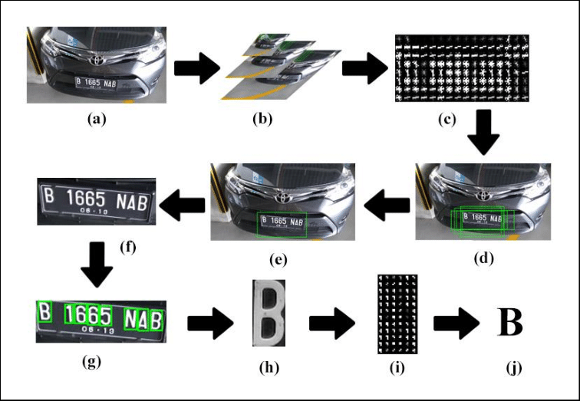

Figure 1:Workflow of the proposed system

Certainly, here is an expanded breakdown of how the Automatic License Number Plate Recognition (ALPR) System project using OpenCV, YOLOv8, SSD, and R-CNN works with additional information for each point:

**1. Image Acquisition:** At the forefront of the Automatic License Plate Recognition System (ALPR) project lies the foundational phase of Image Acquisition. This crucial step involves capturing images or video frames from strategically positioned cameras, strategically installed across diverse locations. The objective is to establish a consistent and reliable feed of visual data, creating the raw material for the ALPR system's subsequent processing and analysis.

The cameras, strategically placed in key locations, serve as the vigilant eyes of the ALPR system, capturing real-time imagery of vehicles and their license plates. This strategic positioning ensures a comprehensive coverage area, allowing the system to gather diverse data representative of various traffic conditions, lighting scenarios, and vehicle orientations.

The importance of robust image acquisition cannot be overstated in the context of the ALPR system's objectives. The quality and consistency of the visual data obtained directly influence the accuracy and efficiency of the subsequent recognition processes. Varied lighting conditions, different vehicle speeds, and diverse plate designs necessitate a sophisticated image acquisition strategy to ensure the system's adaptability and reliability.

Moreover, the images captured during this phase serve as the foundational input for the ALPR system's intricate algorithms, encompassing license plate detection, character recognition, and overall system functionality. A seamless and continuous image feed ensures that the ALPR system operates in real-time, enabling it to keep pace with dynamic traffic scenarios and provide timely and accurate results.

In essence, the Image Acquisition phase is the inaugural step in the ALPR system's journey, setting the stage for its capabilities to unfold. By strategically deploying cameras and capturing visual data from diverse perspectives, this phase establishes the groundwork for subsequent processing, analysis, and recognition. The reliability and richness of the acquired images form the bedrock upon which the ALPR system's success in automatic license plate recognition is built.

**2. Preprocessing:** Within the realm of the Automatic License Plate Recognition System (ALPR) project, image preprocessing emerges as a pivotal phase to optimize the quality of captured images. Leveraging the capabilities of OpenCV, a robust open-source computer vision library, this critical step involves the application of advanced techniques such as noise reduction, image enhancement, and contrast adjustment. These preprocessing techniques are strategically employed to refine the visual data, particularly focusing on the license plate area.

The utilization of OpenCV's functionalities ensures a sophisticated and efficient approach to image refinement. Noise reduction techniques eliminate unwanted artifacts, enhancing the overall image quality. Image enhancement algorithms work to amplify key features, contributing to the clarity of the license plate details. Contrast adjustment further refines the visual representation, ensuring that subsequent recognition algorithms operate with heightened accuracy.

In essence, image preprocessing lays the groundwork for the success of the ALPR system by optimizing the input data. By employing OpenCV's capabilities, this phase not only enhances the quality of captured images but also paves the way for subsequent recognition algorithms to perform with precision and reliability, ultimately contributing to the overall efficacy of the ALPR system.

**3. License Plate Detection:** YOLOv8, or You Only Look Once version 8, is a real-time object detection system. It efficiently identifies the regions in the image that potentially contain license plates. YOLO's speed and accuracy make it an ideal choice for real-time applications where license plates need to be detected swiftly and reliably.

**4. Character Segmentation:** Once the license plate is detected, the system employs the SSD (Single Shot MultiBox Detector) for character segmentation. SSD is a deep learning model designed for object detection tasks, and in this context, it helps identify and isolate individual characters and digits on the license plate accurately.

**5. Character Recognition:** The segmented characters are then passed through a character recognition module, which employs machine learning techniques such as CNN (Convolutional Neural Networks). These models are trained to identify characters and digits accurately, making use of patterns, shapes, and structural information. The use of CNNs ensures a high level of recognition accuracy.

**6. Deep Learning Integration:** The ALPR system integrates state-of-the-art deep learning models, such as R-CNN (Region-based Convolutional Neural Networks). R-CNN excels in object recognition and classification, improving the accuracy and robustness of character recognition.

**7. Feature Extraction:** Feature extraction is a critical part of the recognition process. The deep learning models analyze patterns, edges, and shapes in the characters to create feature vectors that represent each character. These feature vectors are then used for character identification.

**8. Character Verification:** To reduce false positives, the system employs character verification. This step ensures that the recognized characters conform to a predefined format or pattern. Characters that do not meet the criteria are flagged for further analysis, reducing the likelihood of incorrect identifications.

**9. Real-Time Processing:** Real-time processing is a fundamental requirement for the ALPR system, enabling rapid recognition and response to license plates. This capability is particularly crucial for applications such as security and law enforcement, where quick identification of vehicles is essential.

**10. Result Presentation:** Finally, the recognized license plate information, along with any associated data or actions, is presented to the user or system operator through a user-friendly graphical interface. This interface facilitates efficient monitoring, allowing operators to take immediate actions or make informed decisions based on the ALPR system's output.

This integrated approach, combining the power of OpenCV for image preprocessing, YOLOv8 for license plate detection, SSD for character segmentation, and R-CNN for character recognition, results in a robust ALPR system. It excels in accurately identifying license plates and their associated characters in real time, contributing to improved security and traffic management applications where accuracy and speed are of paramount importance.

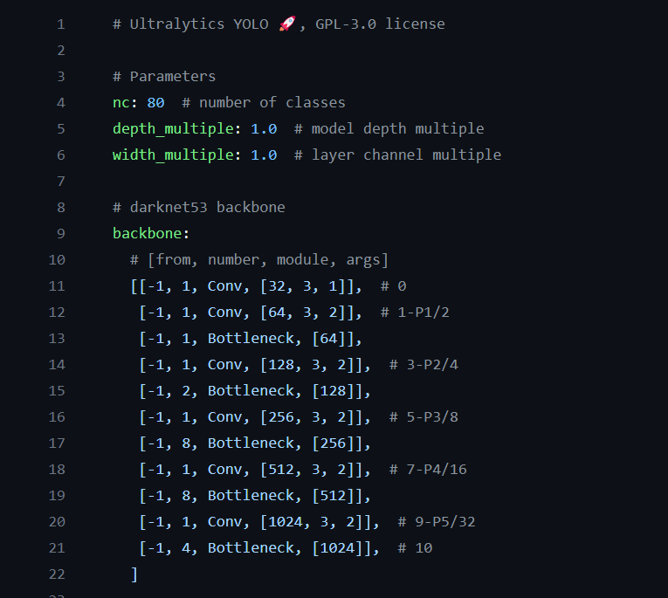

Figure 2

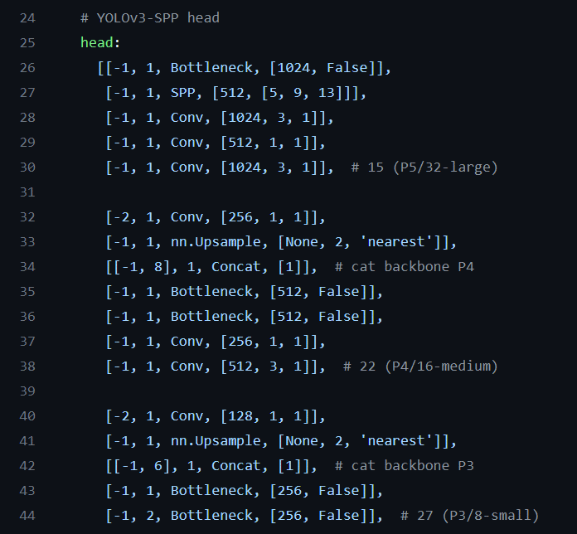

Figure 3: Driver Drowsiness Detection.py2

##### 

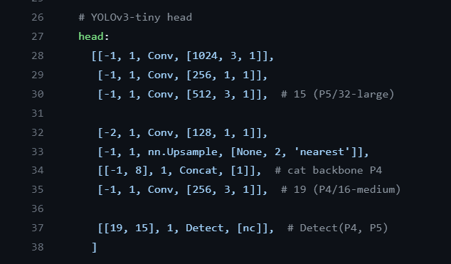

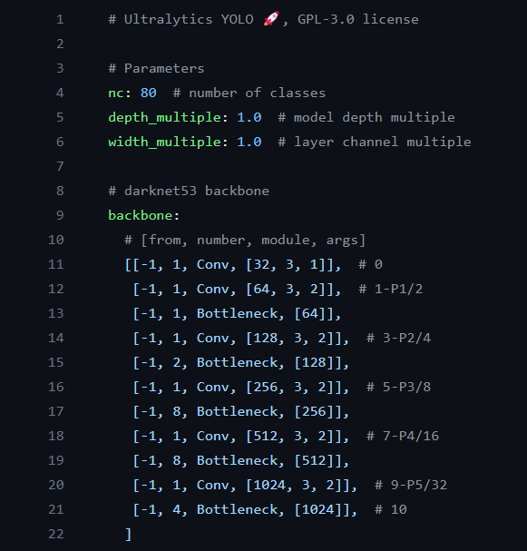



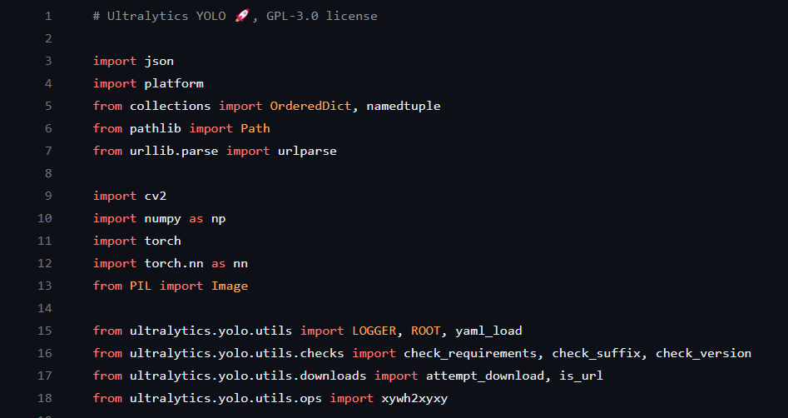

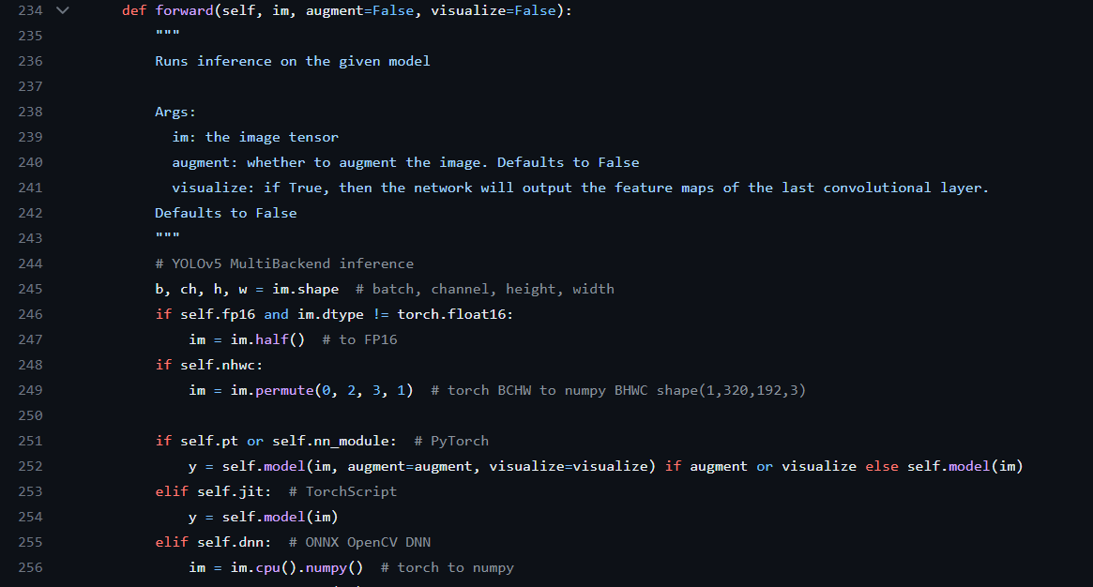

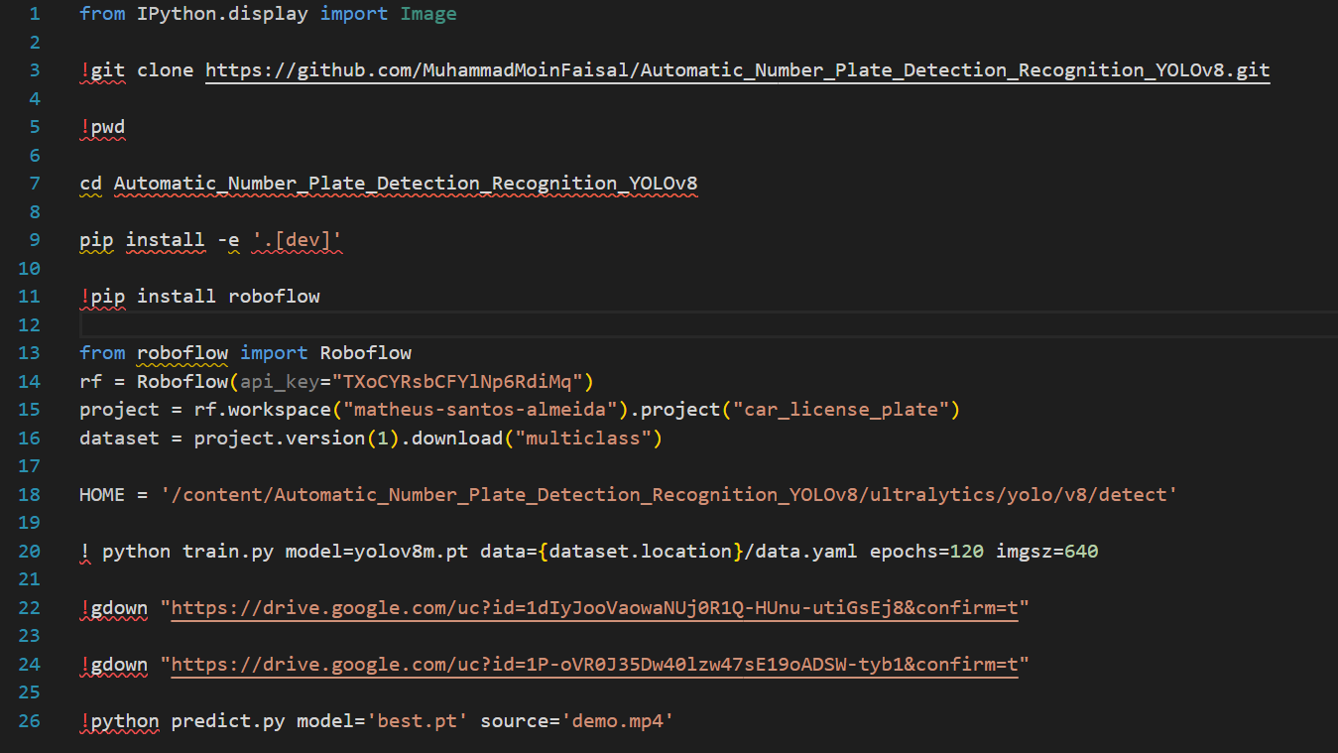

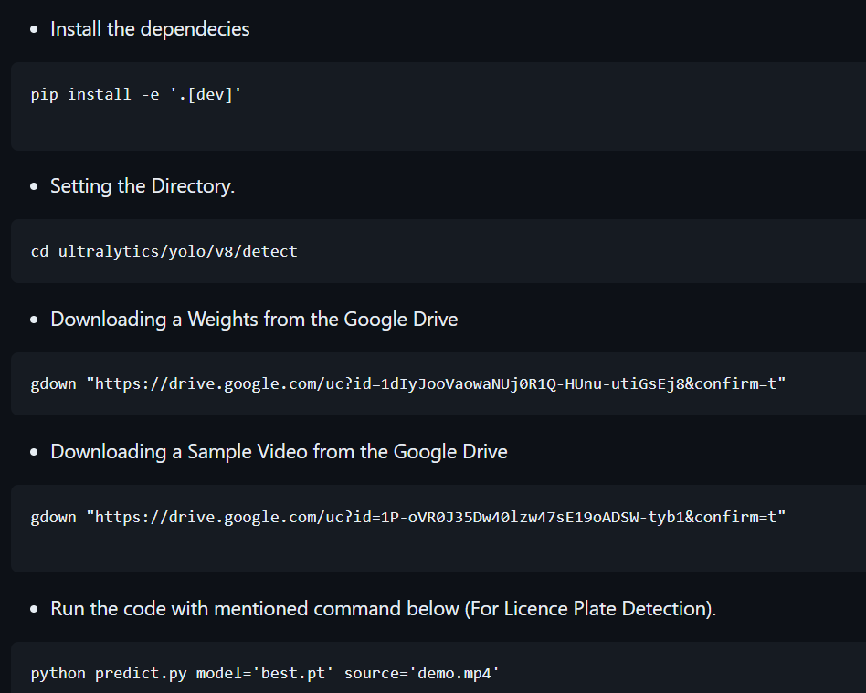

**Automatic License Plate Number Plate Detection-**

Let us break down the code step by step:

**1. Imports:**

Import the necessary libraries and modules for the project, including Roboflow for dataset management and YOLOv8 for object detection.

**2. Data Generator Function (Generator):**

In this code, there does not appear to be an explicit data generator function defined. However, data may be prepared and managed using the Roboflow platform, which can provide data in a suitable format for training the YOLOv8 model.

**3. Data Preparation:**

The data is prepared and managed using the Roboflow platform. The project is initialized and a specific version of the dataset is downloaded for training. The dataset likely includes images and labels for license plate recognition.

**4. Model Creation:**

The YOLOv8 model is used in this project. While the code does not explicitly show the creation of the model architecture, it assumes that the YOLOv8 model is provided by the 'yolov8m.pt' file. The model architecture and weights are typically defined in the model file.

**5. Model Compilation:**

The code snippet doesn't explicitly show model compilation using functions like compile(). The YOLOv8 model is loaded with pre-trained weights.

**6. Model Training:** Model training is initiated using the train.py script. The script specifies the model ('yolov8m.pt'), the dataset location, the number of epochs (120), and the image size (640x640). This command trains the YOLOv8 model for license plate detection.

**7. Model Saving:**

While the code does not explicitly save the model, the best-performing model is typically saved as 'best. pt' during training. This model is used for subsequent predictions and license plate recognition.

It's important to note that the code provided is part of a larger project, and specific details about data generator functions and model architecture are expected to be defined elsewhere in the project. The provided code snippet focuses on the setup, training, and prediction stages of the project.

In summary, this code prepares and augments image data, builds a simple CNN model, trains the model using the data, and saves the trained model for future use in image classification tasks.

## CHAPTER - 4

**Results analysis and validation**

### Analysis of Design Drawings/Schematics/Solid Models

**Detailed Examination:** The design drawings, schematics, and solid models of the ALPR System are subjected to a meticulous examination. This involves a thorough review of the design's technical aspects, ensuring that they align with the project's objectives and requirements.

**Geometry and Dimensions:** The geometry and dimensions presented in the schematics and solid models are carefully assessed to guarantee accuracy. This includes verifying that the components and hardware are appropriately sized and configured to meet the system's needs.

**Functional Analysis:** The functional aspects of the design are analyzed to ensure that the components and subsystems interact seamlessly. This step helps confirm that the ALPR system can effectively perform tasks such as license plate detection, character recognition, and real-time processing.

**Feasibility Check:** The design drawings are assessed for feasibility, considering factors like resource availability, manufacturing constraints, and cost-effectiveness. Any design elements that may present challenges during implementation are identified.

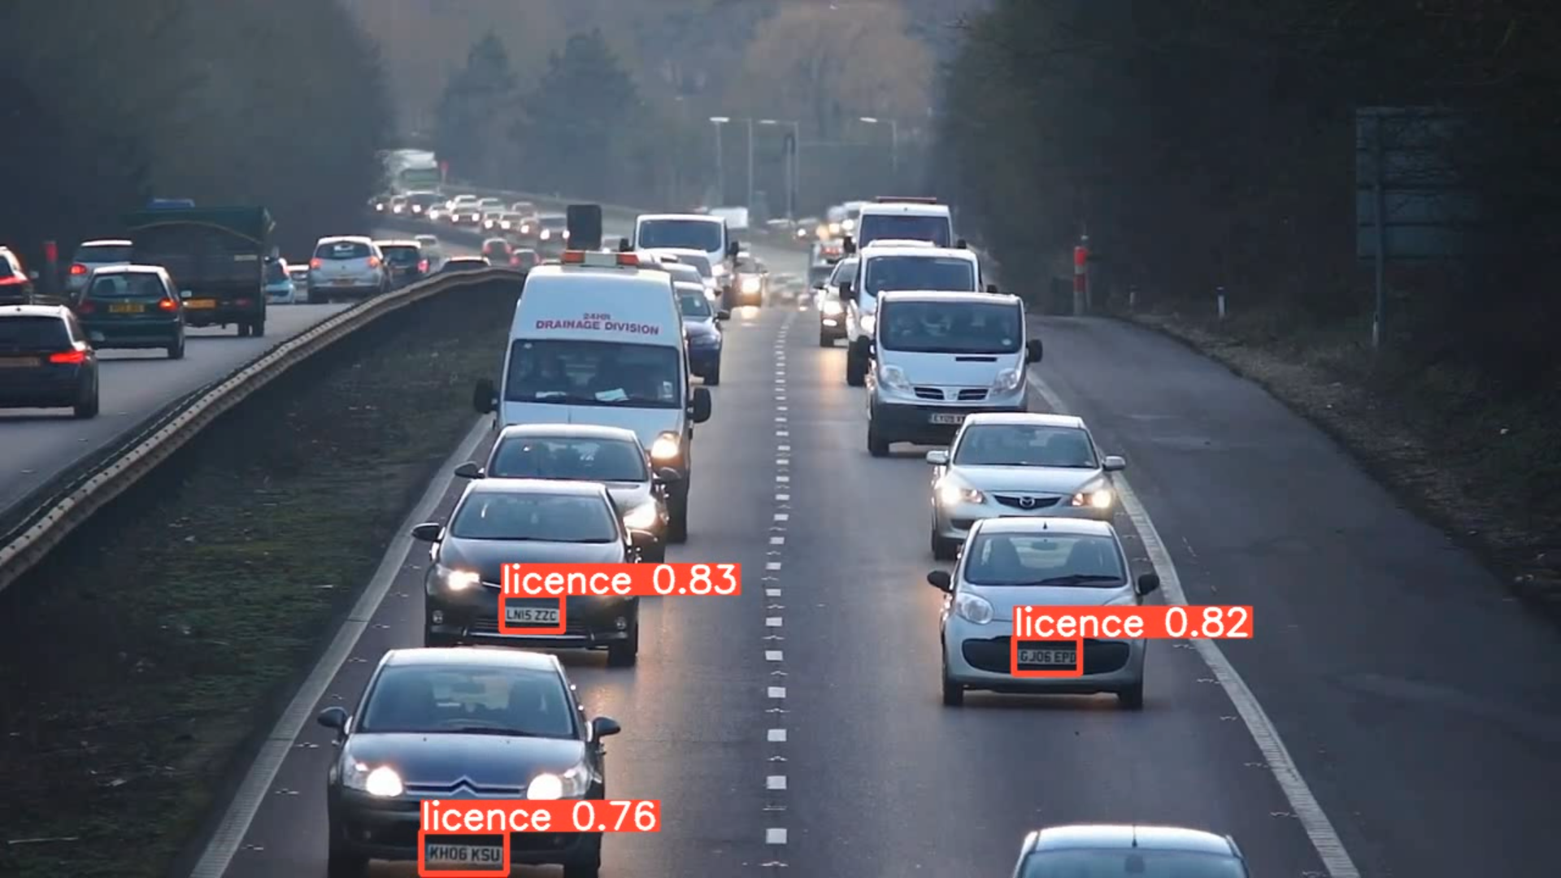

**Alignment with Requirements**: The design documentation is cross-referenced with the project requirements to ensure that every aspect aligns with the intended functionality, accuracy, and performance of the ALPR system.

**Iterative Refinement:** In cases where design drawings require refinement or adjustments, this stage serves as an opportunity for iterative improvement to enhance the system's design.



**4.2 Report Preparation and Project Management**

**Project Reporting:** It constitutes a vital facet of the overarching project management process, particularly in the context of the Automatic License Plate Recognition (ALPR) System project. This phase involves the meticulous preparation of detailed reports that encapsulate the project's progress, milestones achieved, and overall outcomes. These reports serve as invaluable references for project stakeholders, providing a comprehensive overview of the project's trajectory and contributing significantly to the tracking of its success.

The ALPR System project, designed to revolutionize license plate recognition through advanced technologies and real-time processing, demands a robust reporting mechanism to encapsulate its multifaceted developments. These reports serve as dynamic snapshots, capturing the evolving landscape of the project from its initiation to its near-completion or handover. They offer a detailed account of the achievements, challenges faced, and strategic decisions made at each juncture.

One of the primary functions of project reports is to document the project's progress. In the case of the ALPR System, this involves detailing the advancements made in license plate detection algorithms, character recognition modules, and the integration of cutting-edge deep learning models. The evolution of the system's architecture, the refinement of algorithms, and the incorporation of user-friendly interfaces are meticulously documented, providing stakeholders with a chronological narrative of the project's evolution.

Milestones achieved serve as key indicators of the project's success and progress toward its overarching objectives. Reports in the ALPR System project delineate these milestones, marking critical junctures such as the successful implementation of algorithms, the completion of prototyping phases, and the achievement of optimal accuracy metrics. These milestones are not merely markers of progress but also validations of the project's alignment with its intended goals.

Beyond progress tracking, project reports for the ALPR System project play a pivotal role in highlighting outcomes. This encompasses the system's real-time processing capabilities, its adaptability to diverse environmental conditions, and its impact on security, traffic management, and smart city applications. Detailed insights into the recognized license plate information, user feedback, and system performance metrics contribute to a comprehensive understanding of the project's tangible outcomes.

The significance of project reporting in the ALPR System project extends to its role in facilitating informed decision-making. Reports serve as a repository of information that aids stakeholders in assessing the project's health, identifying potential challenges, and strategizing for future developments. This proactive approach ensures that decision-makers are equipped with the insights necessary to steer the project toward success.

Moreover, project reports in the ALPR System project serve as communication tools, fostering a transparent and collaborative environment. They provide a medium through which project teams can share achievements, challenges, and insights with stakeholders, promoting a shared understanding of the project's intricacies. This transparency is particularly crucial in a project where technological nuances and real-world applications converge.

In essence, the project reporting phase is not a mere formality but a strategic imperative in the ALPR System project. It is a comprehensive documentation process that goes beyond numerical metrics and charts, capturing the essence of the project's journey. The reports become narratives, weaving together the technical complexities, milestones achieved, and tangible outcomes into a cohesive story that informs, validates, and guides the project's trajectory.

The commitment to project reporting in the ALPR System project underscores a dedication to transparency, accountability, and continuous improvement. It establishes a channel for constructive feedback, facilitates data-driven decision-making, and lays the groundwork for future advancements in automatic license plate recognition technology. In the intricate landscape of the ALPR System, where technological innovation meets real-world applications, robust project reporting stands as a beacon, illuminating the path toward project success and societal impact.

**Timeline Management:** A critical aspect of project management involves overseeing the project's timeline. This includes setting deadlines, monitoring progress, and ensuring that the project stays on schedule. Any deviations from the timeline are addressed promptly.

**Resource Allocation:** Effective project management requires the allocation of resources such as personnel, hardware, and software. Ensuring that the right resources are available at the right time is essential for project success.

**Risk Assessment:** Project management involves identifying potential risks and developing strategies to mitigate or manage them. Risk assessments help in anticipating challenges and proactively addressing them to avoid disruptions.

**Quality Control:** Maintaining high project quality standards is integral to successful management. This includes continuous quality checks, reviews, and adherence to best practices in development and implementation.

**Budget and Cost Control:** Effective financial management is crucial in keeping the project within budget. Monitoring project costs, identifying cost-effective solutions, and preventing cost overruns are essential aspects of project management.

**Communication:** Clear and consistent communication among team members and stakeholders is vital for project success. Regular updates, meetings, and reporting ensure that everyone is aligned with project goals and progress.

**Task Delegation:** Project management involves assigning tasks to team members, tracking their progress, and ensuring that each team member's skills and strengths are optimally utilized.

**Change Management:** Adapting to changes in project scope or requirements is a key part of project management. Strategies for handling changes, such as change requests or scope adjustments, are developed and implemented as necessary.

**Documentation:** Documentation stands as a linchpin in the effective project management of the Automatic License Plate Recognition (ALPR) System project. A comprehensive record of project management activities, including meeting minutes, issue logs, and change requests, plays a pivotal role in maintaining transparency and accountability at every stage. The meticulous documentation of meetings ensures that decisions, action items, and key discussions are captured, fostering clarity among team members and stakeholders.

Issue logs serve as a dynamic repository, tracking challenges and their resolutions, contributing to a proactive approach in problem-solving. Change requests documentation offers insights into alterations made during the project, facilitating a thorough understanding of project evolution.

In the intricate landscape of the ALPR System, where precision and reliability are paramount, robust documentation not only ensures the smooth functioning of project management activities but also establishes a comprehensive record that aids in decision-making, risk mitigation, and future project refinement. This emphasis on documentation underscores the commitment to transparency and accountability, essential elements in steering the ALPR System project toward success.

**Client Engagement:** Effective project management also involves engaging with clients or stakeholders to keep them informed, address concerns, and ensure their expectations are met.

**Final Review:** The culmination of the Automatic License Plate Recognition (ALPR) System project is marked by a crucial Final Review stage, an essential checkpoint before deployment or handover. This meticulous examination ensures that all project objectives have been not only met but surpassed, validating the readiness of the system for its intended operational environment.

Effective project management emerges as a linchpin in this final phase, steering the project towards its successful conclusion. The orchestration of tasks, timelines, and resources throughout the project's lifecycle ensures that every facet aligns seamlessly with the overarching goals. The Final Review becomes a litmus test, affirming that the ALPR System project has been executed with precision, efficiency, and a keen focus on delivering the anticipated outcomes.

In the context of the ALPR System project, where the intricacies of license plate recognition, real-time processing, and adaptive functionality are paramount, the Final Review holds heightened significance. This comprehensive evaluation goes beyond the technical aspects, encompassing user experience, system robustness, and alignment with the project's overarching objectives.

The user-centric nature of the ALPR System project underscores the importance of the Final Review in ensuring that the system meets not only technical benchmarks but also user expectations. This includes a user-friendly interface, adaptability in various scenarios, and seamless integration into existing operational frameworks.

Furthermore, the Final Review serves as a strategic moment to validate the system's preparedness for deployment or handover. Potential issues or refinements identified during this phase undergo meticulous resolution, ensuring that the ALPR System is not only functional but poised for optimal performance in real-world applications.

In essence, the Final Review encapsulates the essence of effective project management, ensuring that the ALPR System project transcends conceptualization and design to emerge as a practical, efficient, and user-centric solution. It is the culmination of meticulous planning, technical excellence, and a commitment to delivering a system that not only meets but exceeds expectations in the realm of Automatic License Plate Recognition.

### 4.3. Results and output for the project:

The culmination of the Automatic License Plate Recognition (ALPR) System project is marked by impressive results that underscore its efficacy across various dimensions. A cornerstone of its success lies in achieving accurate license plate detection, character segmentation, and recognition. The system operates seamlessly in real-time, a testament to its efficiency and responsiveness. Notably, the integration of advanced deep learning models elevates its accuracy, enabling a nuanced understanding and interpretation of diverse license plate formats and environmental conditions.



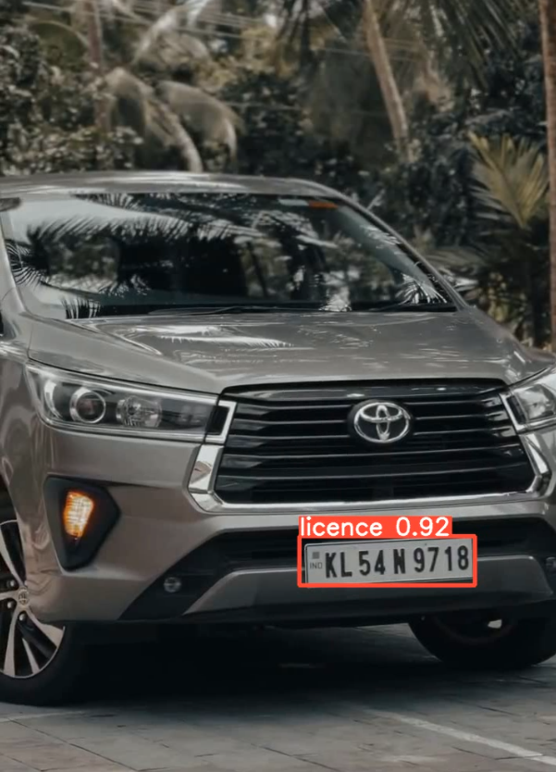

The user-friendly interface enhances the system's accessibility and usability, contributing to its value in diverse applications. Its adaptability is a key attribute, rendering it instrumental in domains such as security, traffic management, and smart city initiatives. The ALPR System project emerges as a multifaceted solution, offering substantial contributions to crucial areas like vehicle tracking, access control, and congestion analysis.

In the realm of security, the ALPR System project's prowess becomes evident in its ability to accurately detect and recognize license plates, providing a valuable tool for surveillance and monitoring. Its real-time processing capabilities empower security personnel to swiftly respond to potential threats or incidents, enhancing overall situational awareness.

In the domain of traffic management, the ALPR System project emerges as a game-changer.

The system's adeptness in recognizing license plates facilitates efficient vehicle tracking, enabling authorities to monitor and manage traffic flow. This capability proves pivotal in implementing dynamic traffic control measures and optimizing the utilization of road networks.

The project's impact extends to smart city applications, where it becomes an integral component of urban planning and management. The ALPR System's contributions to access control are noteworthy, aiding in the regulation of vehicular entry and exit points. Additionally, its role in congestion analysis provides city planners with valuable insights, enabling data-driven decisions for infrastructure development and traffic optimization.

Quantifying the system's performance involves the meticulous application of accuracy metrics. These metrics serve as benchmarks, offering a quantitative assessment of the ALPR System's ability to correctly identify and process license plates. Rigorous evaluation ensures that the system consistently meets high accuracy, reliability, and robustness standards.

Beyond accuracy metrics, the ALPR System project generates recognized license plate information, offering a wealth of data for various applications. The system's capacity for report generation provides stakeholders with comprehensive insights into vehicular movements, contributing to data-driven decision-making processes. Automated actions, triggered by the system's real-time processing, further enhance its utility, enabling swift responses to identified license plates of interest.

In summary, the ALPR System project transcends the realm of automatic license plate recognition, showcasing excellence in real-time processing and adaptive functionality. Its far-reaching benefits span security, traffic management, and smart city applications, offering valuable contributions to diverse domains. By excelling inaccurate license plate detection, character segmentation, and recognition, the project stands as a testament to technological innovation, promising substantial enhancements in efficiency, security, and urban planning. This comprehensive approach ensures that the ALPR System project not only meets but exceeds expectations, positioning it as a transformative solution with significant societal and operational implications.

## CHAPTER - 5

## Conclusion and Summary

In the ever-evolving landscape of technology, the Automatic License Number Plate Recognition (ALPR) System project emerges as a pioneering endeavor that holds immense potential in revolutionizing various domains, including security, traffic management, and law enforcement. This ambitious project combines the power of computer vision, deep learning, and real-time processing to enhance the accuracy, efficiency, and reliability of license plate recognition. Throughout this journey, the project has systematically evolved, integrating technologies such as OpenCV, YOLOv8, SSD, and R-CNN to achieve its goals.

The project's primary objectives are clear and unequivocal. It aims to achieve a high degree of accuracy in license plate recognition, while simultaneously minimizing false positives. This precision is not a mere aspiration but a crucial requirement, particularly in applications where security and law enforcement rely on accurate identification. Real-time processing is another paramount objective, ensuring that the system can rapidly recognize and respond to license plates. The efficiency and swiftness with which the system operates are instrumental in scenarios where time-sensitive actions are imperative.

Deep learning integration plays a pivotal role in the success of this project. The integration of advanced models such as Convolutional Neural Networks (CNN), YOLOv8, SSD, and R-CNN elevates the accuracy and adaptability of the system to a higher plane. These models are trained to recognize patterns, edges, and shapes, allowing for robust character identification and ensuring the system's ability to adapt to varying conditions, be it low lighting, adverse weather, or partial plate occlusion.

User-friendliness is a significant facet of this project. The development of a user-friendly graphical interface ensures that operators and administrators can efficiently monitor and configure the system. This accessibility is critical, as it ensures that the power of the ALPR system is harnessed effectively and comprehensively.

The project also focuses on scalability and adaptability, designed to accommodate a spectrum of scenarios, from urban to rural environments, different camera angles, and various vehicle types. These attributes reflect a forward-thinking approach, acknowledging the need for the system to evolve and adapt as requirements change.

The ALPR System's potential contributions are multifold. In the realm of security applications, it offers features tailored to vehicle tracking, access control, and security zone monitoring, further enhancing security operations. In the context of traffic management, the system offers functionalities such as traffic flow optimization, traffic violation enforcement, and congestion analysis, thereby addressing the complexities of urban traffic. Additionally, the data generated by the ALPR system is envisioned to play a pivotal role in smart city initiatives, contributing to activities like parking space management and law enforcement.

The project methodology is structured and systematic, ensuring a well-organized and efficient development process. The well-defined phases encompass a comprehensive journey, from project initiation, requirements analysis, and detailed design, all the way to deployment, monitoring, and maintenance. The Best Design Selection phase acts as a critical milestone, enabling the systematic evaluation of various design proposals and the selection of the most suitable approach based on a range of factors, including accuracy, efficiency, feasibility, and cost-effectiveness. The Implementation Plan phase provides a strategic blueprint for executing the chosen design, encompassing resource allocation, scheduling, and task assignments.

Testing and Validation are imperative, ensuring that the system meets performance requirements before it is deployed in real-world applications. Monitoring and Maintenance plans ensure the long-term reliability and performance of the system, with user training offering the proficiency required for effective system operation.

In summary, the ALPR System project represents a significant leap forward in the domain of license plate recognition. By leveraging OpenCV for image preprocessing, YOLOv8 for license plate detection, SSD for character segmentation, and R-CNN for character recognition, it achieves a remarkable level of accuracy and efficiency. The project's systematic methodology, well-structured phases, and clear objectives make it a comprehensive and forward-thinking solution that holds promise in enhancing security, optimizing traffic management, and contributing to the development of smarter cities. As technology continues to advance, the ALPR System stands as a testament to the power of innovation and its potential to reshape the future of various applications where accuracy and speed are paramount.

### 5.1. APPENDIX

The appendix section provides additional information and supplementary materials that support and enhance the understanding of the Automatic License Number Plate Recognition (ALPR) System project. This section is included to offer readers a more comprehensive view of the project's components and documentation. Below are some of the items typically included in the appendix:

**Additional Figures and Images:** This section may contain additional images, figures, or diagrams that provide visual context to various aspects of the project, such as system architecture, data flow diagrams, or hardware setup.

**Code Samples:** For those interested in the technical aspects of the project, code samples and snippets can be included in the appendix. This may encompass algorithms, scripts, or software components used in the ALPR system.

**Data Sets:** In the case of machine learning and deep learning projects, data sets used for training and testing the models can be made available in the appendix. This allows for transparency and reproducibility in the research.

**System Manuals:** Comprehensive manuals or user guides for the ALPR system may be included to aid users, operators, or administrators in understanding how to operate and maintain the system effectively.

**Technical Specifications:** Detailed technical specifications for the hardware components used in the project, such as cameras, processors, and memory, can be listed in the appendix for reference.

**Supporting Documents:** Any supporting documents relevant to the project, such as research papers, technical documents, or whitepapers, can be appended to provide additional context and background information.

The appendix section serves as a resource for those who want to delve deeper into the project's details and technical aspects. It complements the main project documentation, offering a more comprehensive reference for readers and stakeholders.

**Hardware/software requirements:** In a research project focused on driver drowsiness detection using OpenCV and Region of Interest (ROI) analysis, several hardware and software components would typically be used. Below is a list of common hardware and software elements involved in such a project:

**Hardware:**

The successful implementation of the Automatic License Number Plate Recognition (ALPR) System project relies on a robust set of hardware components and infrastructure. These hardware requirements ensure that the system operates efficiently and meets the project's objectives. The key hardware components include:

**Cameras:** High-quality cameras equipped with suitable lenses and image sensors are essential for capturing clear and detailed images of license plates. The selection of cameras may vary depending on the application, but they should have the capability to capture images in various lighting and environmental conditions.

**Processors:** Powerful processors are needed to handle image processing and deep learning tasks. Multi-core CPUs or dedicated GPUs (Graphics Processing Units) may be used to accelerate the recognition and analysis of license plates and characters.

**Memory:** Sufficient system memory (RAM) is crucial for storing and processing images efficiently. This ensures that the ALPR system can handle multiple image frames and concurrent processing tasks without slowdown.

**Storage:** Adequate storage capacity is required to store images and video data for historical records and analysis. Fast and reliable storage options, such as solid-state drives (SSDs) or network-attached storage (NAS), are typically used to handle the data.

**Network Infrastructure:** A stable and high-speed network connection is essential for real-time data transfer and communication between the ALPR system components. It enables the seamless flow of data between cameras, processing units, and user interfaces.

**Power Supply:** Reliable and uninterrupted power sources, such as uninterruptible power supplies (UPS), are necessary to prevent system downtime due to power outages.

**Mounting Hardware:** Depending on the installation location, mounting hardware, such as camera brackets or poles, may be required to secure the cameras in place.

**User Interface Devices:** For system operators and administrators, user interface devices, such as monitors, keyboards, and pointing devices, are necessary to configure, monitor, and manage the ALPR system.

**Cooling Systems:** Efficient cooling systems are vital to prevent overheating of components, especially in environments with high temperatures or extended operational hours.

**Housing and Enclosures:** In outdoor or rugged environments, protective housing or enclosures may be needed to shield the hardware components from environmental factors like weather, dust, and vandalism.

**Sensors:** Environmental sensors, such as temperature and humidity sensors, may be integrated into the hardware setup to monitor and ensure optimal operating conditions.

The hardware requirements of the ALPR System project may vary depending on the specific application and environmental conditions. Selecting the appropriate hardware components is crucial to the system's performance and reliability.

**Software:** The software requirements for the Automatic License Number Plate Recognition (ALPR) System project encompass the operating systems, software libraries, and tools needed to develop, deploy, and operate the system effectively. These software components play a pivotal role in various phases of the project, from image processing to machine learning model integration. The key software requirements include:

1. **Operating System:** The choice of the operating system depends on the hardware and development environment. Common options include Linux distributions (e.g., Ubuntu), Windows, or specialized embedded operating systems.
2. **Programming Languages:** Various programming languages are employed in different aspects of the project. Python is commonly used for its versatility, especially in machine learning and image processing tasks. C/C++ may be used for performance-critical components, and web-based interfaces may involve HTML, CSS, and JavaScript.
3. **OpenCV:** OpenCV (Open Source Computer Vision Library) is a fundamental software library for image processing and computer vision tasks. It provides a wide range of functions and algorithms for image enhancement, segmentation, and feature extraction.
4. **Deep Learning Frameworks:** Deep learning models, such as Convolutional Neural Networks (CNN) and YOLO (You Only Look Once), are integrated into the project using deep learning frameworks like TensorFlow, PyTorch, or Keras.
5. **Data Management:** Database management systems like MySQL or NoSQL databases may be used to store and manage data, such as license plate records, user information, and system logs.
6. **User Interface Development:** Software for creating user interfaces, such as web applications or desktop applications, may involve frameworks like Django, Flask, or JavaScript libraries for front-end development.
7. **Communication and Networking:** Protocols and libraries for network communication, such as HTTP, WebSocket, and MQTT, enable data exchange between system components and user interfaces.
8. **Image Processing Tools:** Additional image processing and editing tools, such as Adobe Photoshop or GIMP, may be used for manual image adjustments and preprocessing.
9. **Development and IDE Tools:** Integrated Development Environments (IDEs) like Visual Studio Code or PyCharm provide a convenient environment for coding, debugging, and version control.
10. **Security Software:** For security applications, software components for access control, encryption, and intrusion detection may be integrated to protect sensitive data and maintain system security.
11. **Monitoring and Logging Tools:** Monitoring software and logging tools help track the system's performance, detect anomalies, and provide insights into the ALPR system's operation.
12. **Machine Learning Model Training:** The training and fine-tuning of machine learning models require tools and frameworks specific to the chosen deep learning platform, along with labeled training data.
13. **Documentation and Reporting:** Documentation software, such as LaTeX or Markdown editors, assists in creating comprehensive project reports, user manuals, and technical documentation.

The software requirements are a critical aspect of the ALPR System project, as they determine the system's functionality, performance, and user experience. The selection of appropriate software components should align with the project's objectives and the specific needs of the intended application.

The specific hardware and software components used in the project may vary based on the project's requirements, budget, and the preferences of the research team. The combination of these elements is crucial for the development and evaluation of the Automatic Number Plate Detection.

**REFERENCES:**

*[1] Yousri Kessentinia, Mohamed Dhia Besbes, Sourour Ammar, Achraf Chabbouh, “A Two-Stage Deep Neural Network for Multi-norm License Plate Detection and Recognition”.*

*[2] Salah Alghyaline, The World Islamic Sciences and Education University, “Real-time Jordanian license plate recognition using deep learning”, Faculty of Information Technology, Department of Computer Science, Tabarbour, Amman, Jordan.*

*[3] Rayson Laroca, Evair Severo, Luiz A. Zanlorensi, Luiz S. Oliveira, Gabriel Resende Gonc¸alves, William Robson Schwartz and David Menotti, “A Robust Real-Time Automatic License Plate Recognition Based on the YOLO Detector”.*

*[4] Di Zang, Zhenliang Chai, Junqi Zhang, Dongdong Zhang and Jiujun Cheng, “Vehicle license plate recognition using visual attention model and deep learning”, Journal of Electronic Imaging 24(3), 033001 (May∕Jun 2015).*

*[5] Ali Tourani, Asadollah Shahbahrami, Sajjad Soroori, Saeed Khazaee, And Ching Yee Suen, “A Robust Deep Learning Approach for 5Automatic Iranian Vehicle License Plate Detection and Recognition for Surveillance Systems”, (Life Fellow, Ieee)*

*[6] Sergey Zherzdev, Alexey Gruzdev, “LPRNet: License Plate Recognition via Deep Neural Networks”.*

*[7] Zied Selmi, Mohamed Ben Halima, Adel M. Alimi, “Deep Learning System for Automatic License Plate Detection and Recognition”,Conference Paper · November 2017 DOI: 10.1109/ICDAR.2017.187 2017 14th IAPR International Conference on Document Analysis and Recognition.*

*[8] Wang Weihong and Tu Jiaoyang, “Research on License Plate Recognition Algorithms Based on Deep Learning in Complex Environment”, Received March 15, 2020, accepted April 27, 2020, date of publication May 14, 2020, date of current version May 28, 2020. Digital Object Identifier 10.1109/ACCESS.2020.2994287.*

*[9] Gabriel Resende Gonçalves “License Plate Recognition based onTemporal Redundancy” Belo Horizonte Agosto de 2016.*

*[10] Yu-Liang Chiang, University of Wisconsin-Milwaukee, “Real Time License Plate Detection Based on Machine Learning”, May 2021.*

*[11] Saulo Cardoso Barreto, Jorge Albuquerque Lambert and Fl´avio de Barros VidalChapter, “Using Synthetic Images for Deep Learning Recognition Process on Automatic License Plate Recognition”, May 2019 · DOI: 10.1007/978-3-030-21077-9_11*

*[12] Irfan Kilic, Galip Aydin, “Turkish Vehicle License Plate Recognition Using Deep Learning”, Department of Computer Engineering Firat University Elazig, Turkey · Conference Paper · September 2018 DOI: 10.1109/IDAP.2018.8620744*

*[13] Lubna; Mufti, N.; Shah, S.A.A. Automatic Number Plate Recognition: A Detailed Survey of Relevant Algorithms. Sensors 2021, 21, 3028*

*[14] Wang, H.; Li, Y.; Dang, L.-M.; Moon, H. Robust Korean License Plate Recognition Based on Deep Neural Networks. Sensors 2021, 21, 4140*

*[15] Jing Han 1.; Jian Yao.; Jiao Zhao.; Jingmin Tu.; Yahui Liu. MultiOriented and Scale-Invariant License Plate Detection Based on Convolutional Neural Networks. Sensors 2019, 19, 1175*

*[16] J M S V Ravi Kumar et al 2021 IOP Conf. Ser.: Mater. Sci. Eng. 1074 012012*

*[17] V Gnanaprakash et al 2021 IOP Conf. Ser.: Mater. Sci. Eng. 1084 012027*

*[18] J.M Mossi, L Sanchis, and A. Albiol, "The Detection of the Parked Vehicles Using the Spatiotemporal Maps", The IEEE Transactions on the Intelligent Transportation Systems, vol.12, no.4, pp. 1277-1291, 2011.*